**DiBaseRNA: Database and Atlas of Nucleobase**

**Spatial Arrangements in RNA**

C:\Documents and Settings\Aleksandr Sahakyan\Desktop\toc.tif

Citations:

Sahakyan A.B. and Vendruscolo M, “DiBaseRNA: Database and Atlas of Nucleobase Spatial Arrangements in RNA”, 2013+. <https://github.com/aleksahak/DiBaseRNA>

Sahakyan A.B. and Vendruscolo M. “Analysis of Ring Current and Electric Field Effects on the Chemical Shifts of RNA Bases”, J. Phys. Chem. B, 117, 1989-1998, 2013. <http://dx.doi.org/10.1021/jp3057306>

**AA**

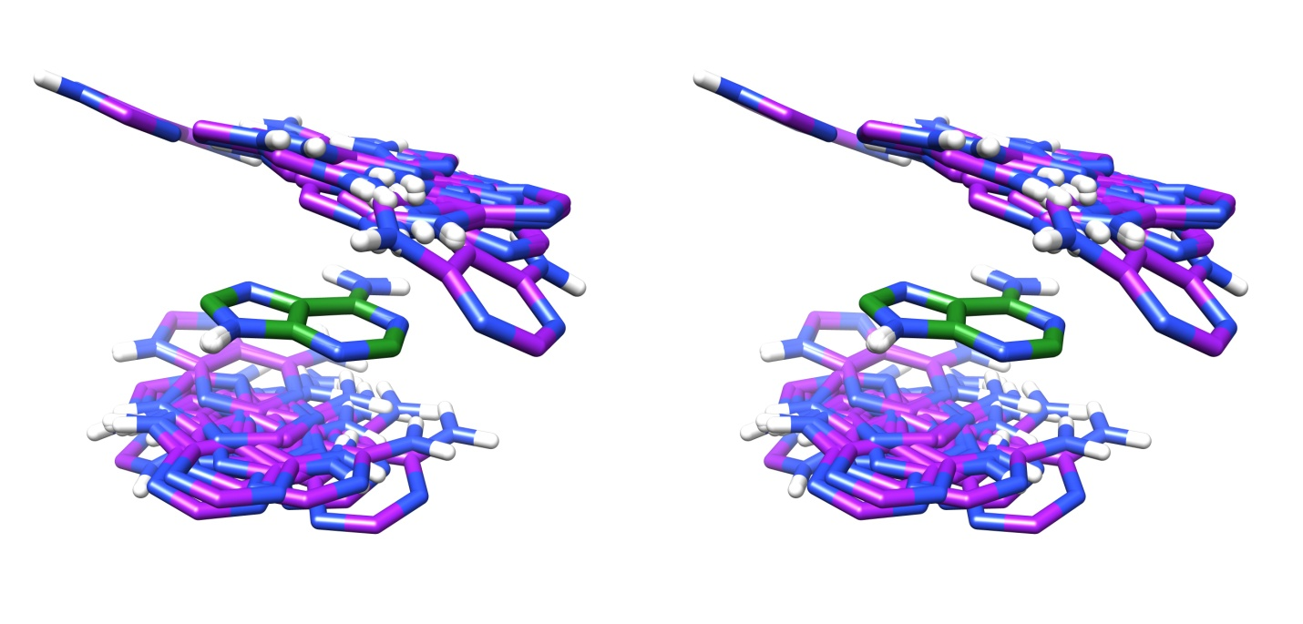

ADJ: superimposed 37 structures of bases in covalently linked adjacent RNA nucleotides.

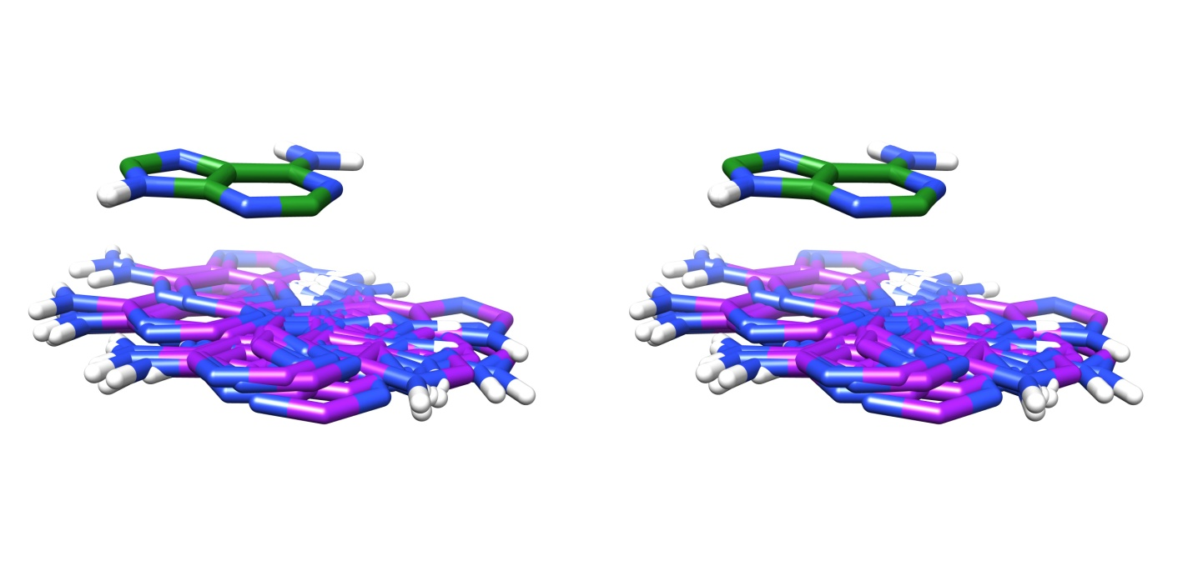

SPT: superimposed 21 structures of bases in only spatially close but not hydrogen bonded nucleotides.

***Figure 1:*** *Inter-ring arrangement patterns of adenine-adenine di-bases in the DiBaseRNA database. Their adjacent (ADJ) and spatial (SPT) states are shown.*

**AC**

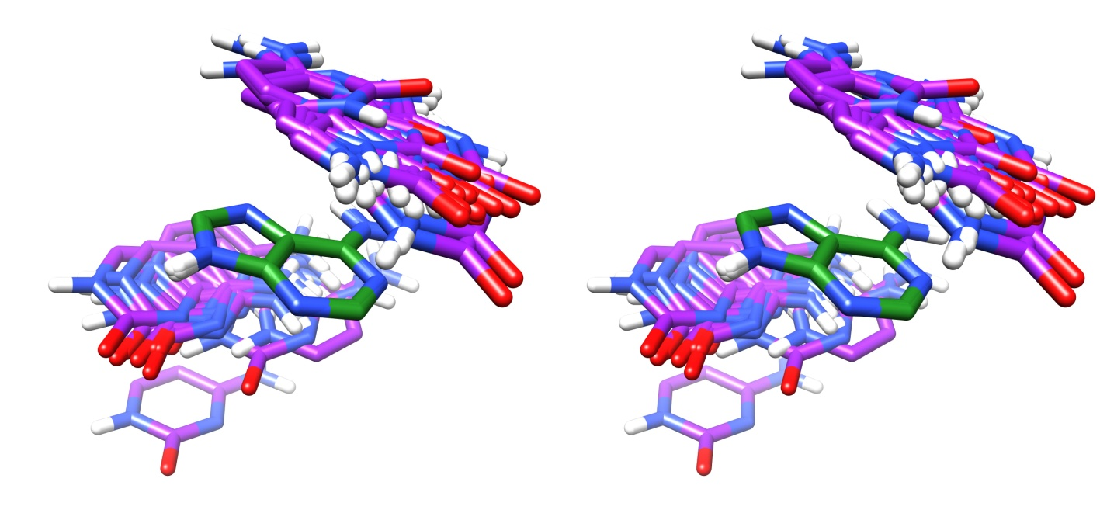

ADJ: superimposed 39 structures of bases in covalently linked adjacent RNA nucleotides.

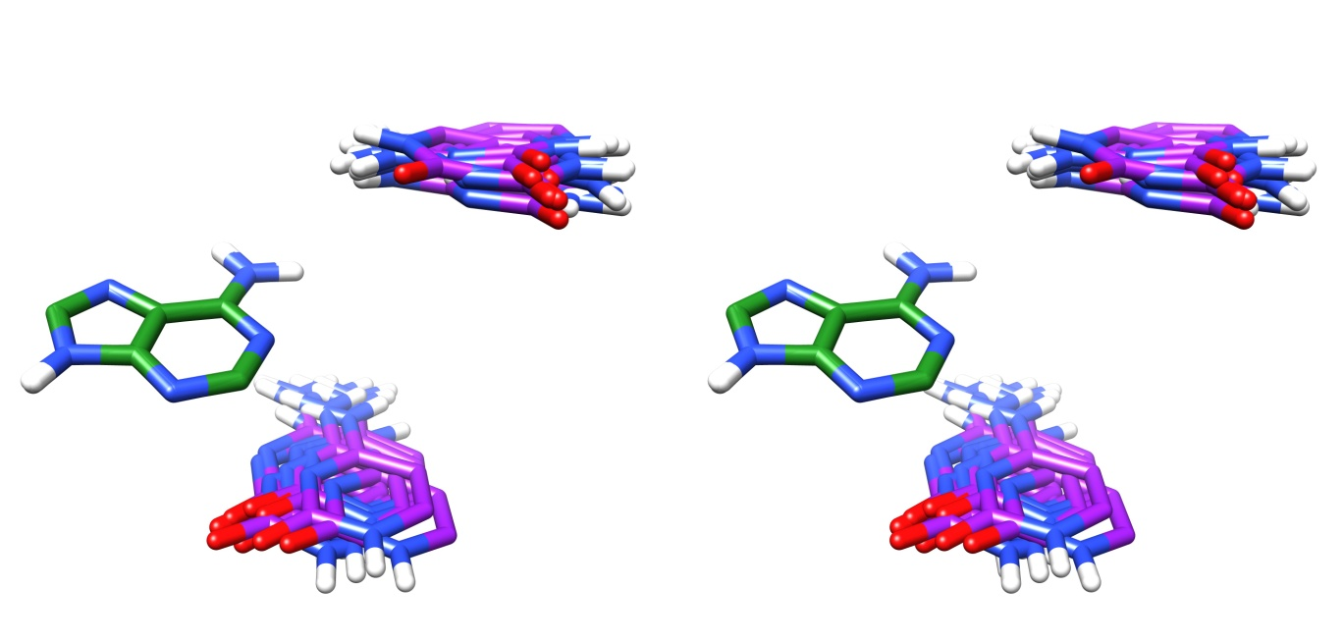

SPT: superimposed 21 structures of bases in only spatially close but not hydrogen bonded RNA nucleotides.

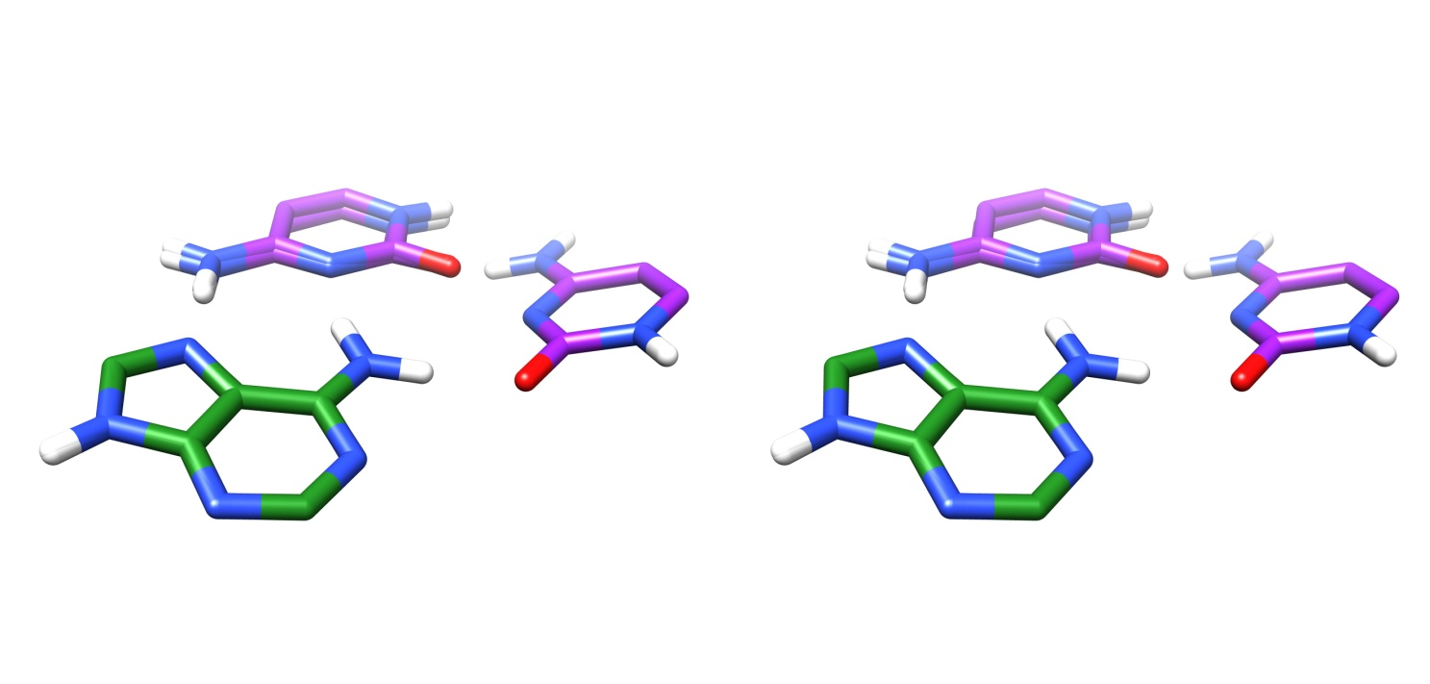

HBD: superimposed 3 structures of bases in hydrogen bonded RNA nucleotides.

***Figure 2:*** *Inter-ring arrangement patterns of adenine-cytosine di-bases in the DiBaseRNA database. Their adjacent (ADJ), spatial (SPT) and hydrogen bonded (HBD) states are shown.*

**AG**

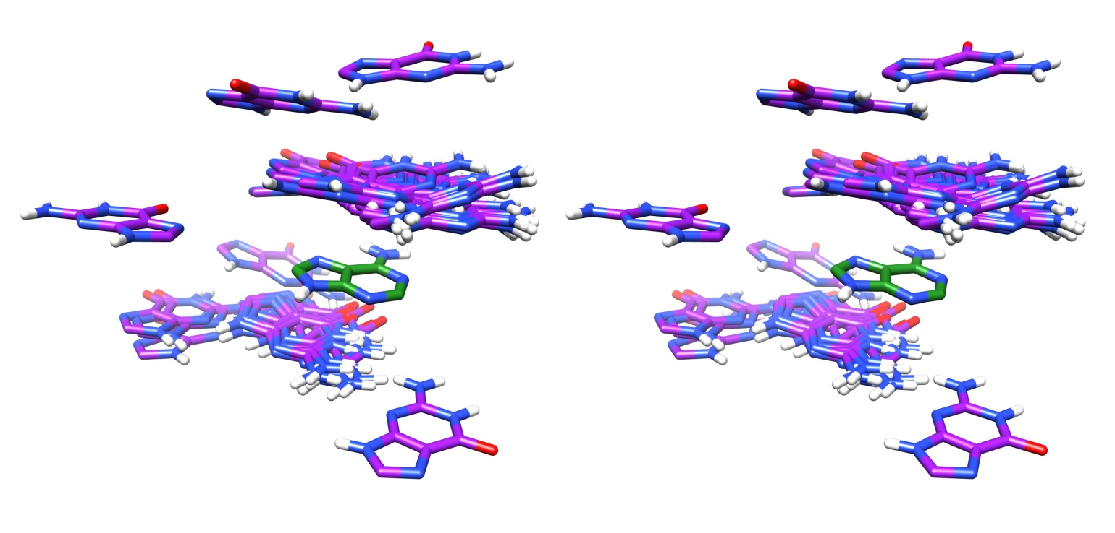

ADJ: superimposed 64 structures of bases in covalently linked adjacent RNA nucleotides.

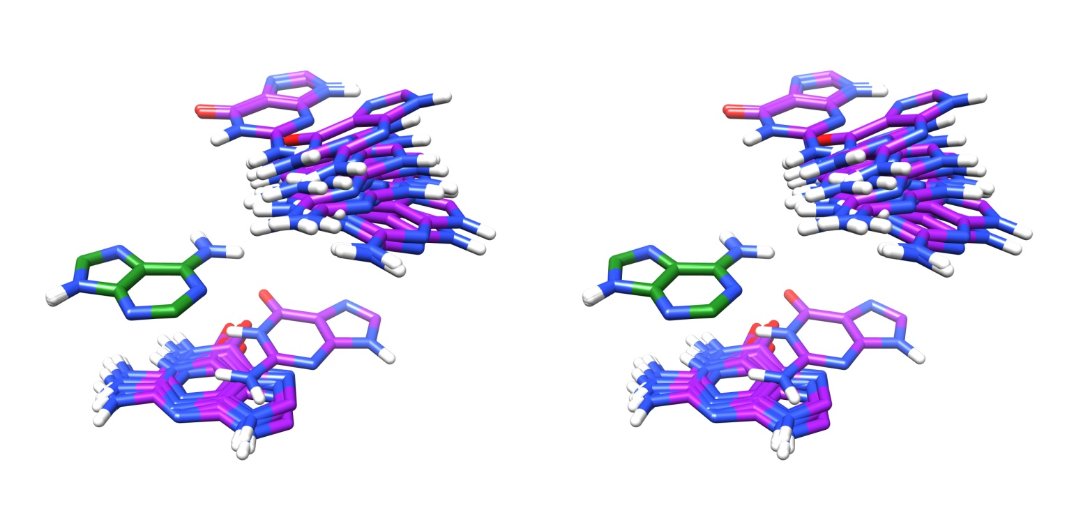

SPT: superimposed 24 structures of bases in only spatially close but not hydrogen bonded RNA nucleotides.

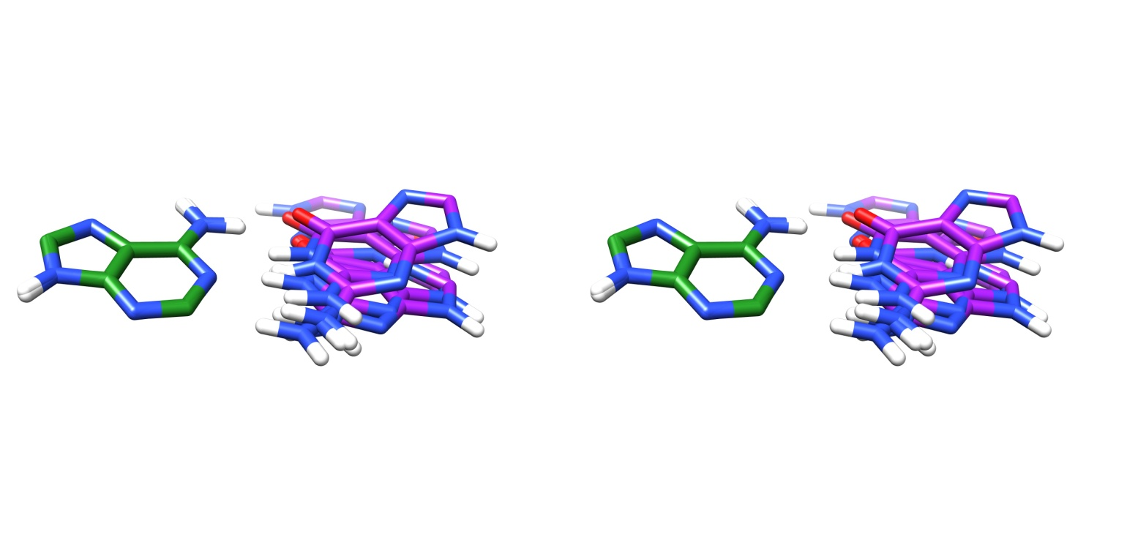

HBD: superimposed 6 structures of bases in hydrogen bonded RNA nucleotides.

***Figure 3:*** *Inter-ring arrangement patterns of adenine-guanine di-bases in the DiBaseRNA database. Their adjacent (ADJ), spatial (SPT) and hydrogen bonded (HBD) states are shown.*

**AU**

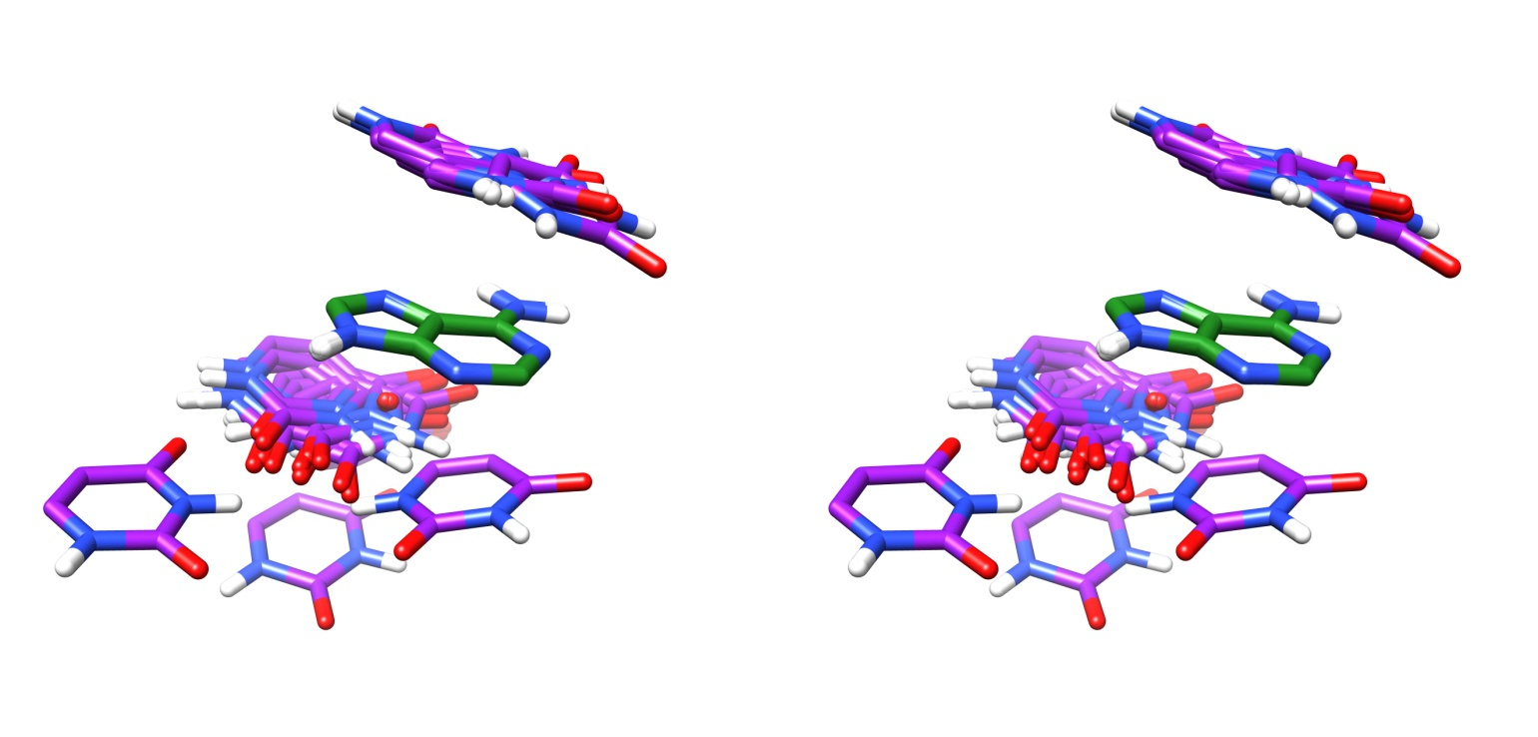

ADJ: superimposed 24 structures of bases in covalently linked adjacent RNA nucleotides.

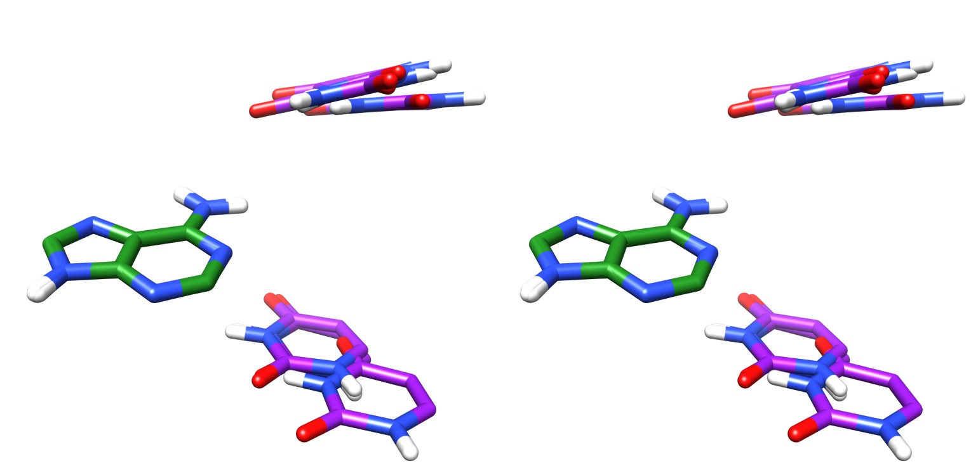

SPT: superimposed 7 structures of bases in only spatially close but not hydrogen bonded RNA nucleotides.

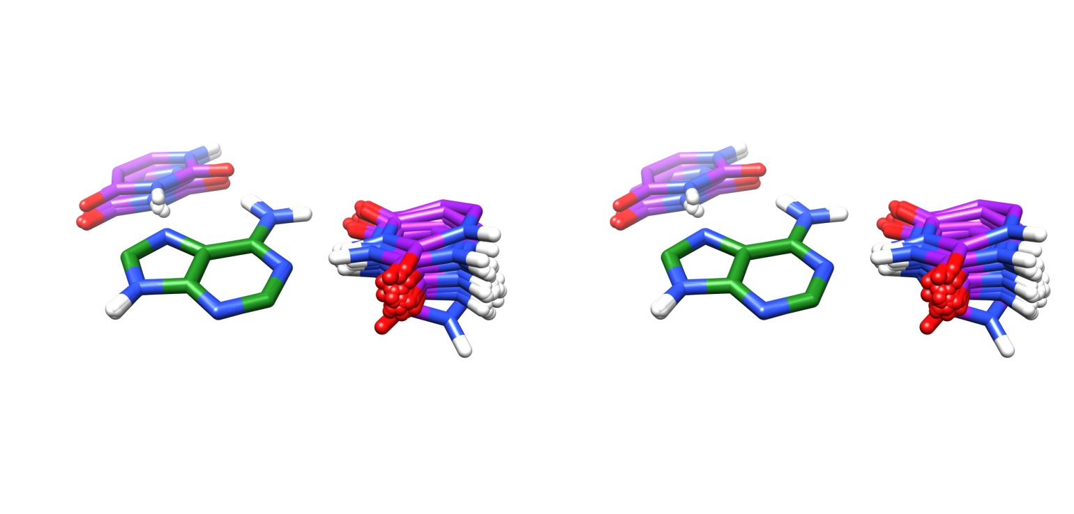

HBD: superimposed 38 structures of bases in hydrogen bonded RNA nucleotides.

***Figure 4:*** *Inter-ring arrangement patterns of adenine-uracil di-bases in the DiBaseRNA database. Their adjacent (ADJ), spatial (SPT) and hydrogen bonded (HBD) states are shown.*

**CC**

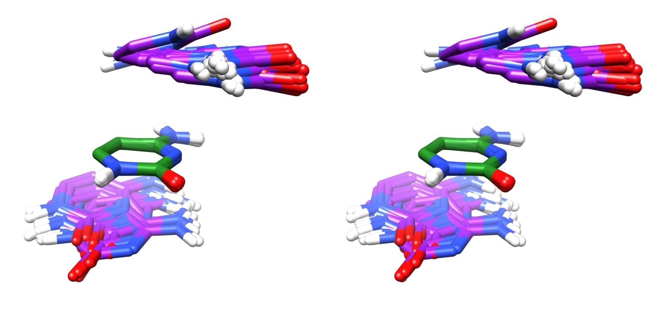

ADJ: superimposed 72 structures of bases in covalently linked adjacent RNA nucleotides.

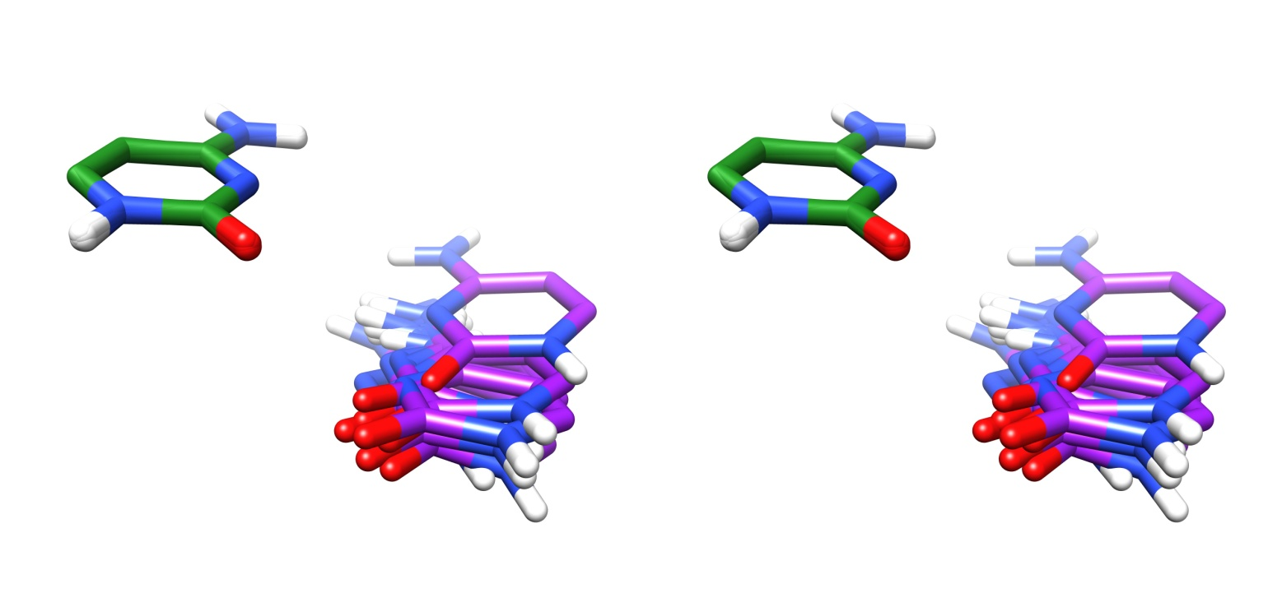

SPT: superimposed 10 structures of bases in only spatially close but not hydrogen bonded RNA nucleotides.

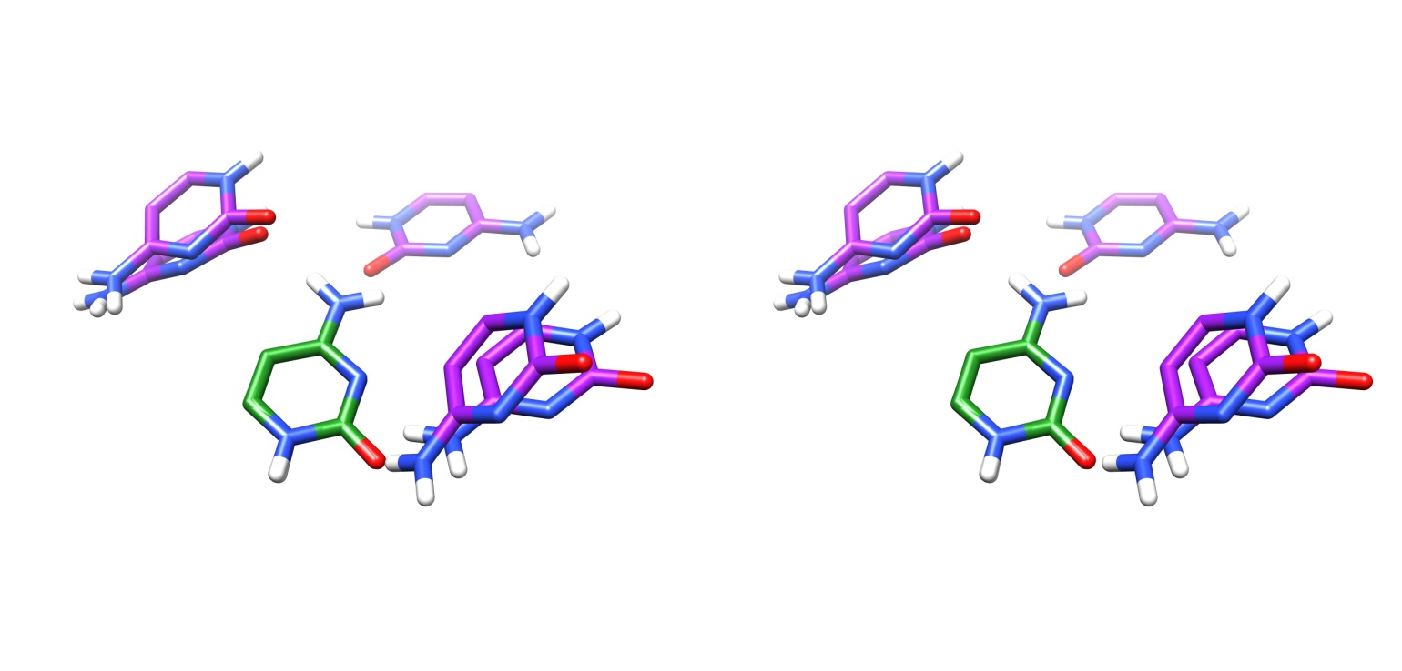

HBD: superimposed 5 structures of bases in hydrogen bonded RNA nucleotides.

***Figure 5:*** *Inter-ring arrangement patterns of cytosine-cytosine di-bases in the DiBaseRNA database. Their adjacent (ADJ), spatial (SPT) and hydrogen bonded (HBD) states are shown.*

**CU**

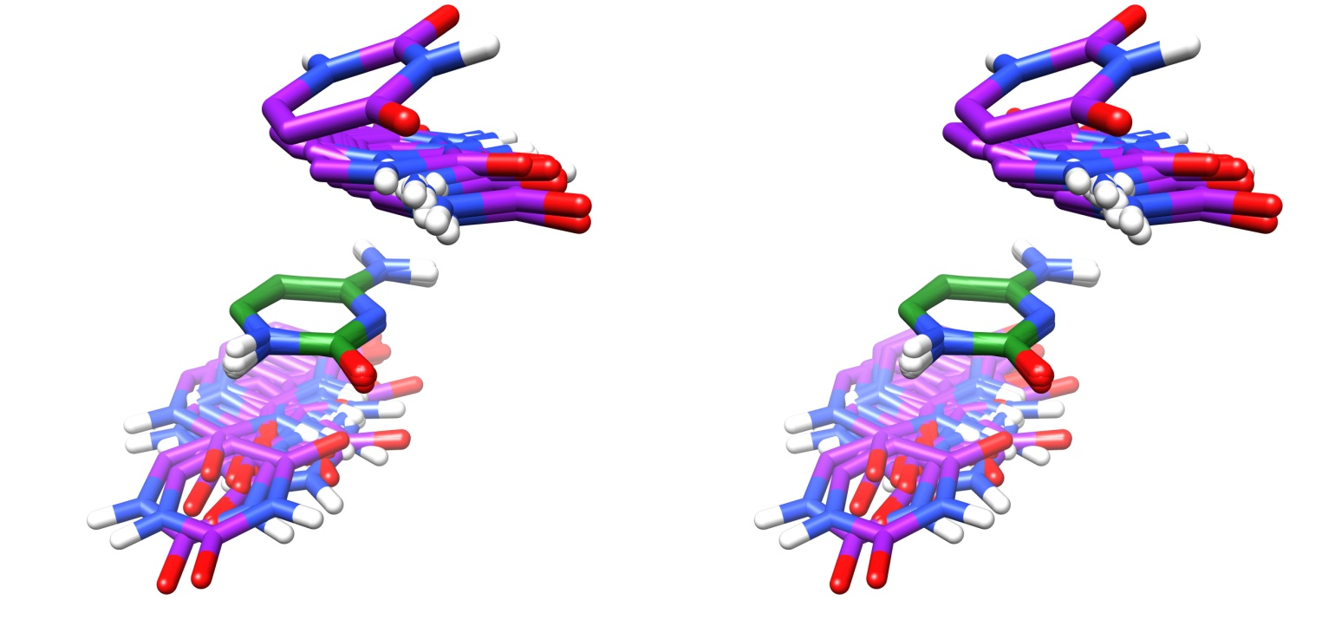

ADJ: superimposed 39 structures of bases in covalently linked adjacent RNA nucleotides.

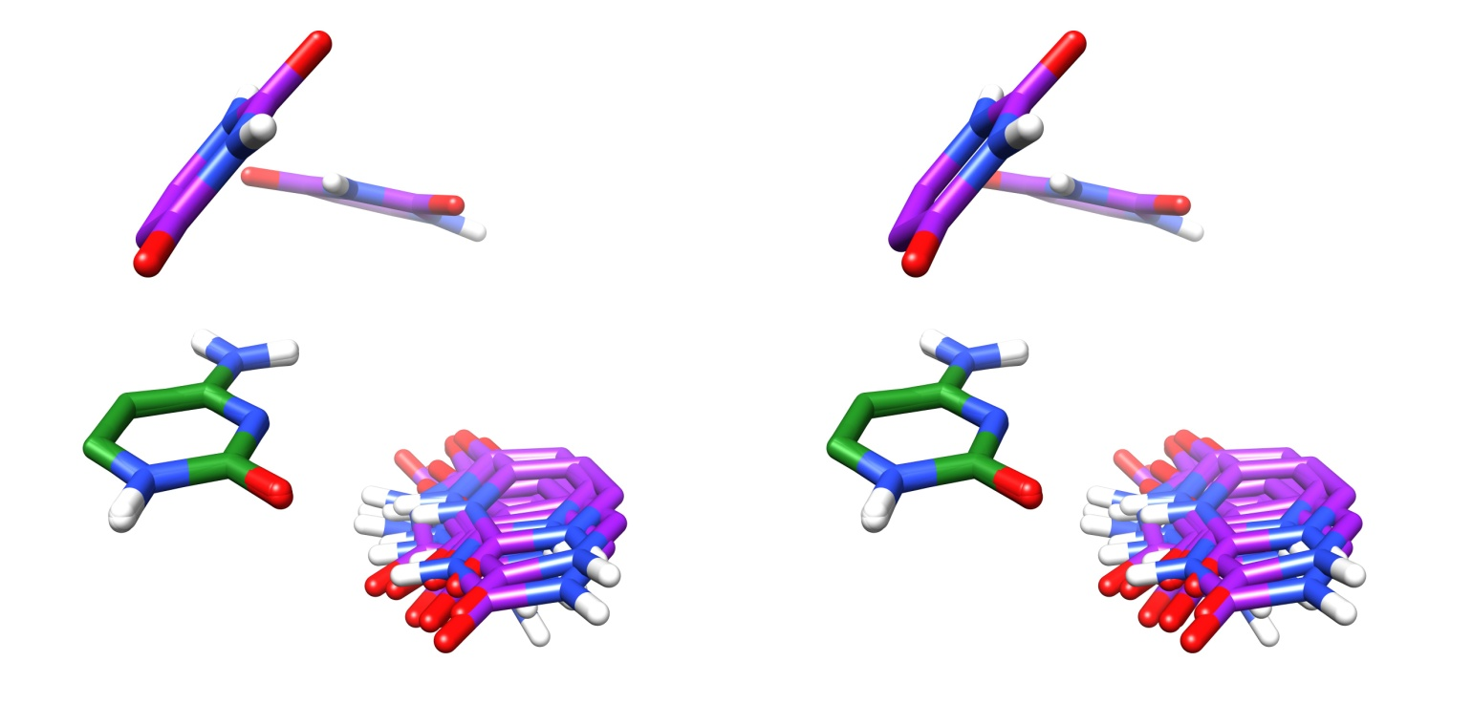

SPT: superimposed 13 structures of bases in only spatially close but not hydrogen bonded RNA nucleotides.

***Figure 6:*** *Inter-ring arrangement patterns of cytosine-uracil di-bases in the DiBaseRNA database. Their adjacent (ADJ) and spatial (SPT) states are shown.*

**GC**

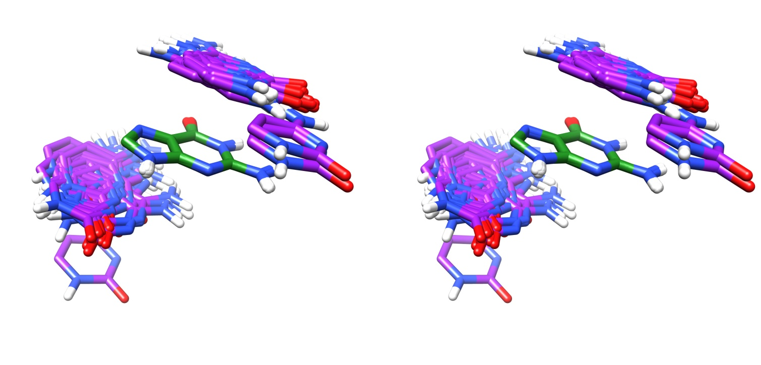

ADJ: superimposed 79 structures of bases in covalently linked adjacent RNA nucleotides.

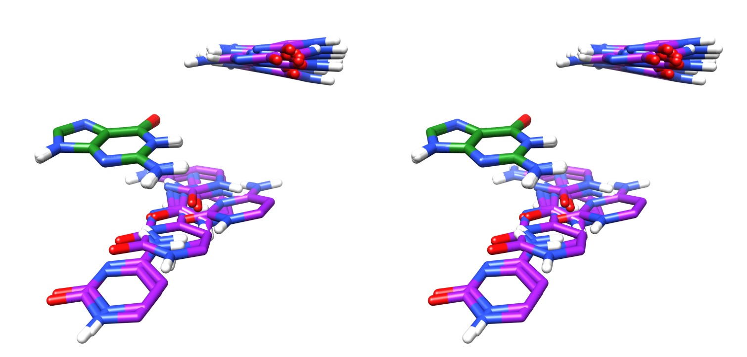

SPT: superimposed 20 structures of bases in only spatially close but not hydrogen bonded RNA nucleotides.

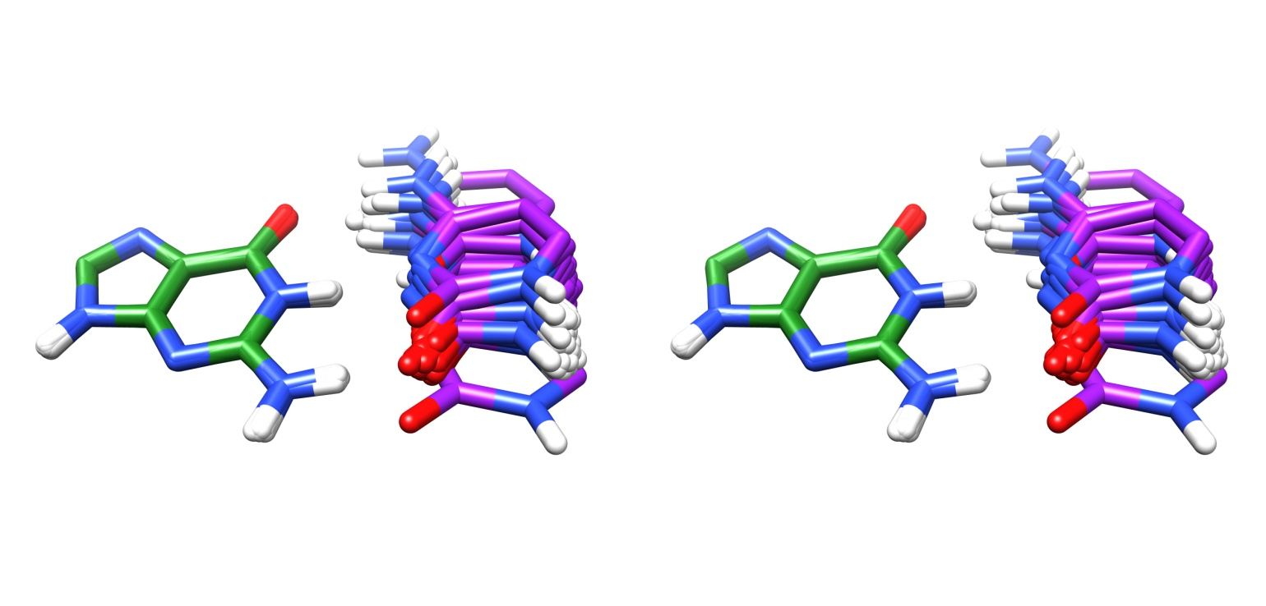

HBD: superimposed 95 structures of bases in hydrogen bonded RNA nucleotides.

***Figure 7:*** *Inter-ring arrangement patterns of guanine-cytosine di-bases in the DiBaseRNA database. Their adjacent (ADJ), spatial (SPT) and hydrogen bonded (HBD) states are shown.*

**GG**

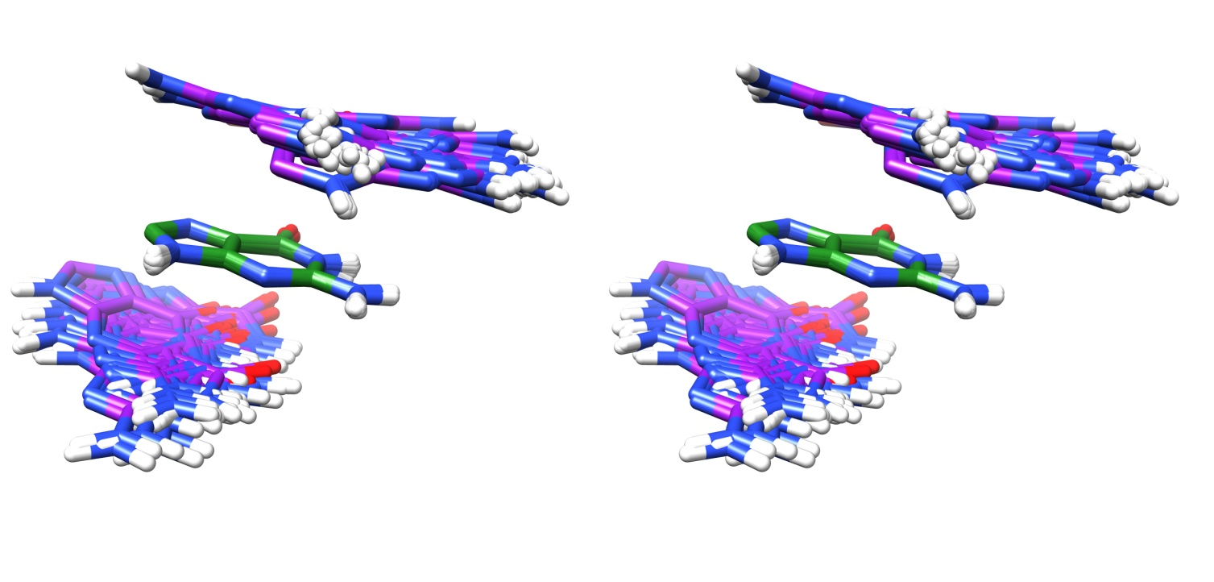

ADJ: superimposed 115 structures of bases in covalently linked adjacent RNA nucleotides.

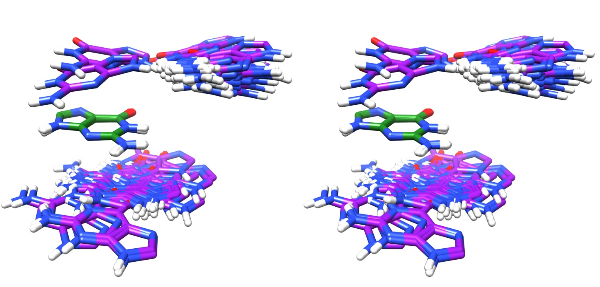

SPT: superimposed 81 structures of bases in only spatially close but not hydrogen bonded RNA nucleotides.

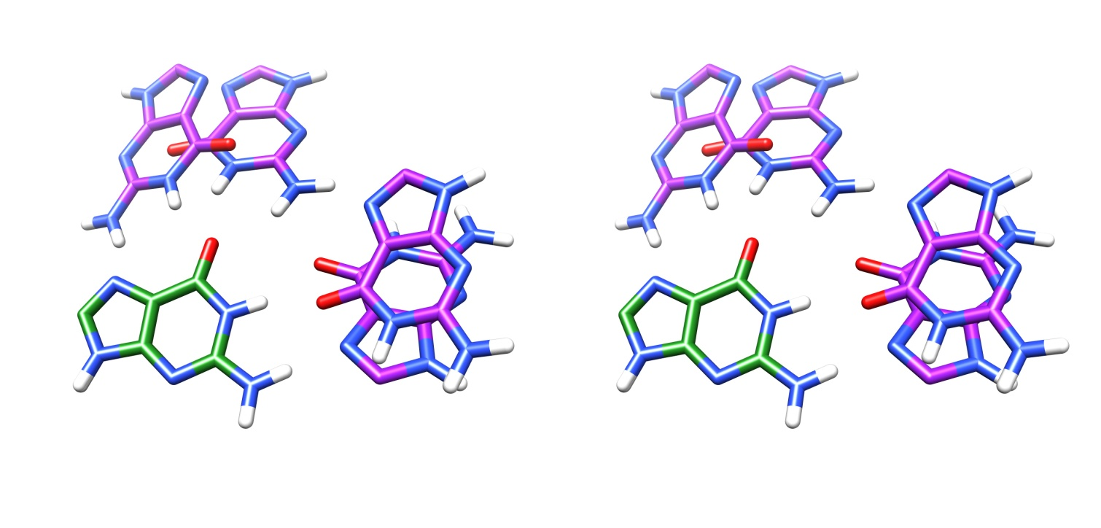

HBD: superimposed 4 structures of bases hydrogen bonded RNA nucleotides.

***Figure 8:*** *Inter-ring arrangement patterns of guanine-guanine di-bases in the DiBaseRNA database. Their adjacent (ADJ), spatial (SPT) and hydrogen bonded (HBD) states are shown.*

**GU**

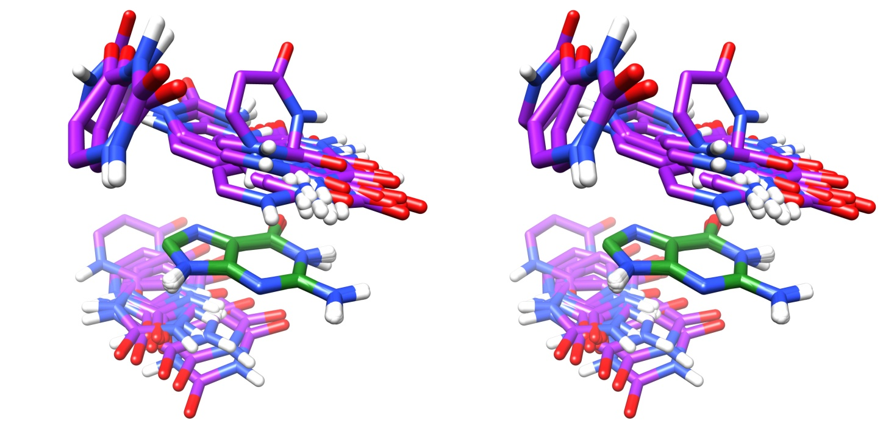

ADJ: superimposed 55 structures of bases in covalently linked adjacent RNA nucleotides.

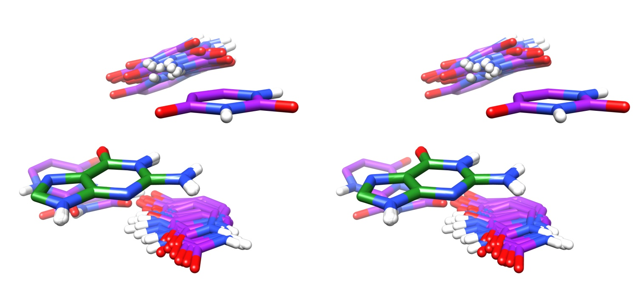

SPT: superimposed 26 structures of bases in only spatially close but not hydrogen bonded RNA nucleotides.

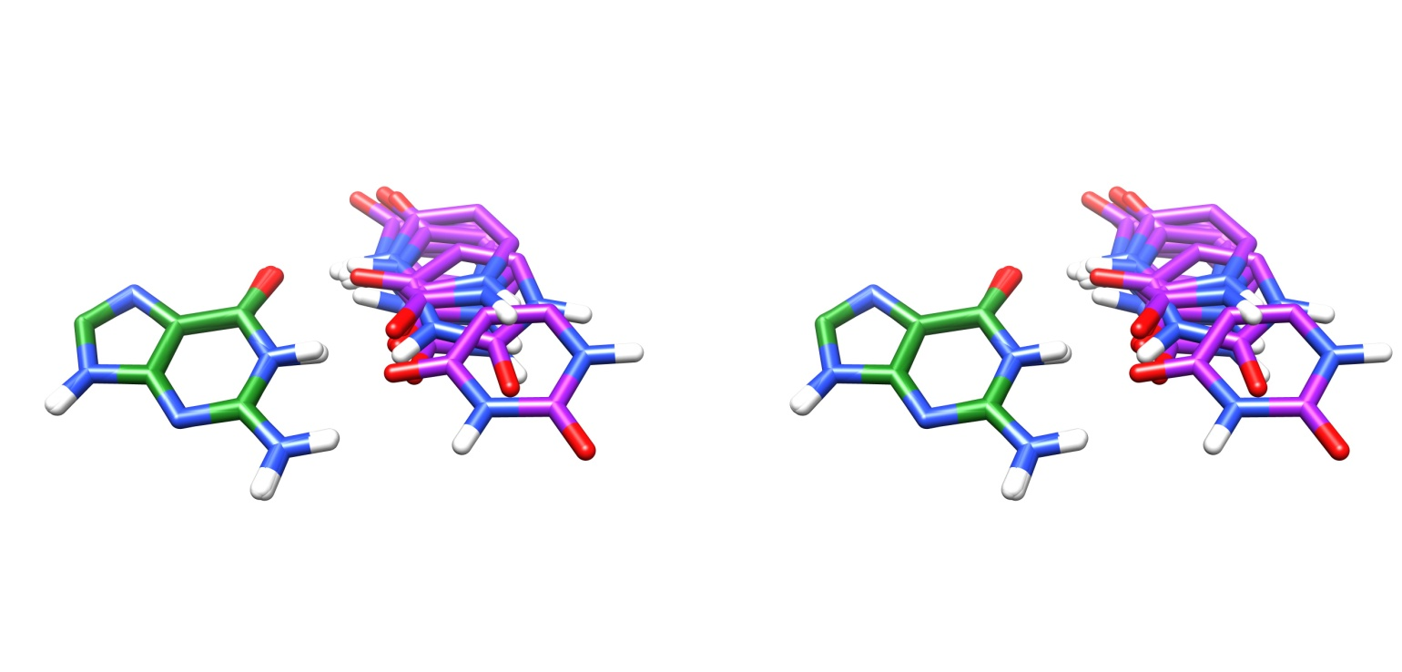

HBD: superimposed 9 structures of bases in hydrogen bonded RNA nucleotides.

***Figure 9:*** *Inter-ring arrangement patterns of guanine-uracil di-bases in the DiBaseRNA database. Their adjacent (ADJ), spatial (SPT) and hydrogen bonded (HBD) states are shown.*

**UU**

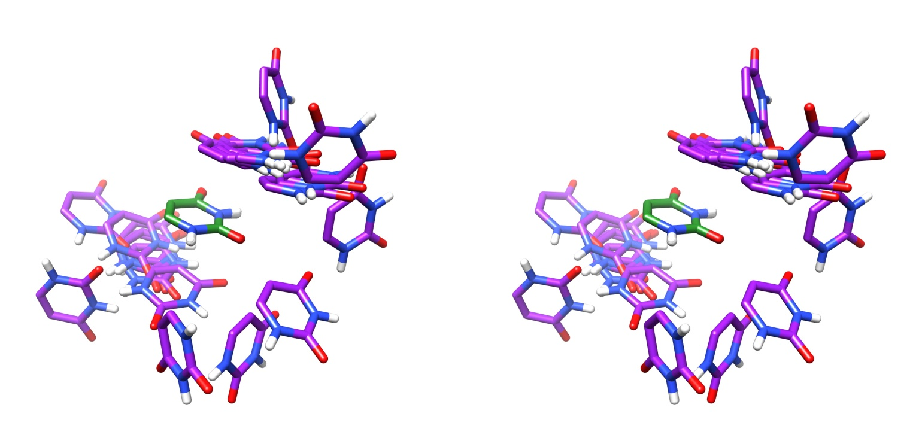

ADJ: superimposed 23 structures of bases in covalently linked adjacent RNA nucleotides.

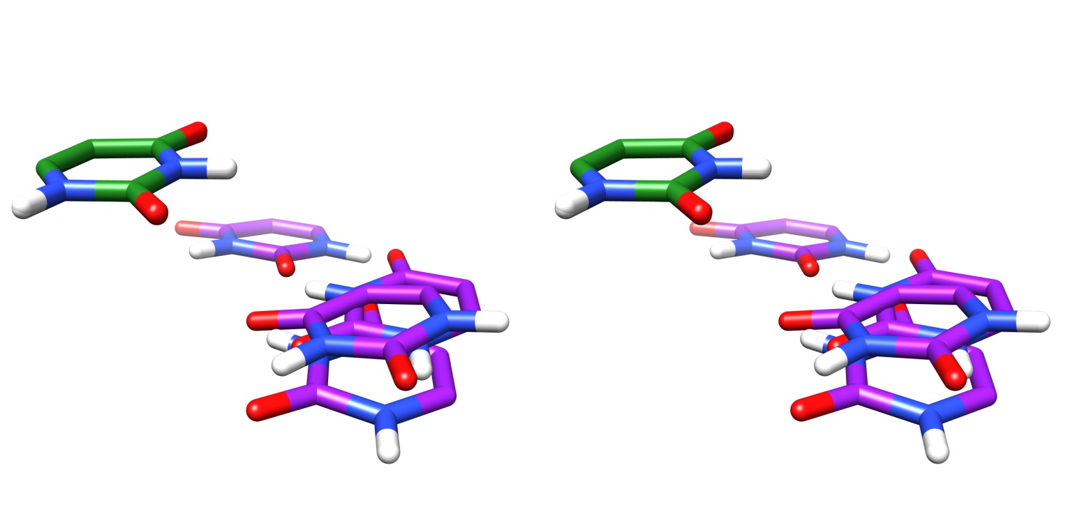

SPT: superimposed 4 structures of bases in only spatially close but not hydrogen bonded RNA nucleotides.

***Figure 10:*** *Inter-ring arrangement patterns of uracil-uracil di-bases in the DiBaseRNA database. Their adjacent (ADJ) and spatial (SPT) states are shown.*